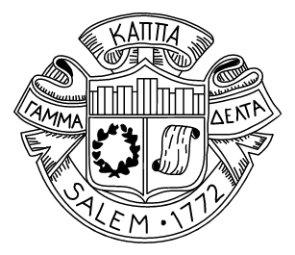
The Salem Academy and College Board of Trustees at its meeting on October 13, 2017, voted to have Salem join the consortium Universities Studying Slavery (USS).
According to the USS website, the consortium “allows participating institutions to work together as they address both historical and contemporary issues dealing with race and inequality in higher education and in university communities as well as the complicated legacies of slavery in modern American society.”
“We believe that we will benefit not only from the historical research conducted by other colleges and universities but also from contemporary conversations related to slavery and to each institution’s history,” Salem Academy and College President D. E. Lorraine Sterritt said in a letter to the community.
Founded in 2015 at the University of Virginia as Virginia’s Colleges and Universities Studying Slavery (VCUSS), the consortium originally included colleges and universities from the state of Virginia and was expanded later that year to include institutions of higher education outside the state. Membership now includes more than twenty-five colleges and universities within the United States, Canada, and the United Kingdom, including Brown University, Georgetown University, Rutgers University, Columbia University, the University of North Carolina, Wake Forest University, Dalhousie University, and the University of Glasgow.
The recommendation to join the consortium was made by the Committee on the History of Salem Academy and College, which endorses having the opportunity to work with other institutions to examine past associations with the institution of slavery and to develop a set of guiding principles that will address this complex and painful issue.

